Please support our charity
Hawaiian Shirt Day
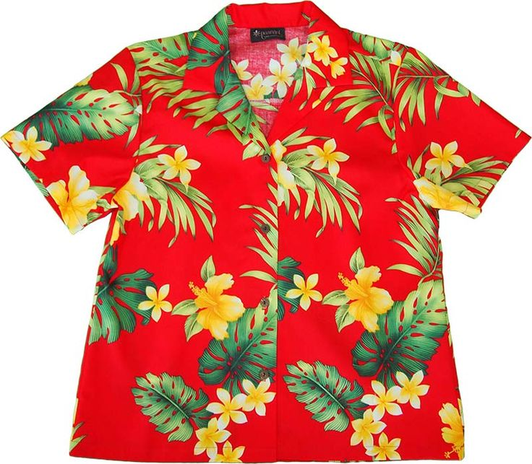

on
Friday 23 June

Simply donate a pound or two & swap your normal work wear for your favourite Hawaiian shirt!
The louder, the jazzier, the brighter, the better!
All proceeds to
Headway Birmingham & Solihull

Improving life after brain injury

Headway Birmingham & Solihull

20 Chapel Rise, Birmingham B45 9SN
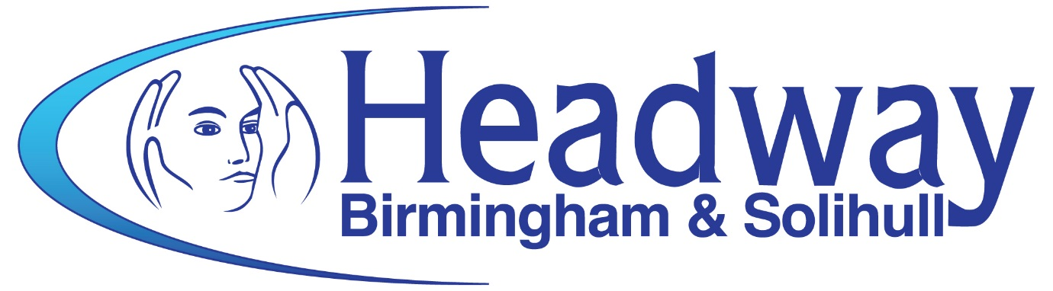
Tel: 0121 457 7541 www.headway-bs.org.uk

Registered Charity No 1008798 Company Registration No 2686647

